Signal Tower Specification

FUB “SGT”

Customer: Vistaprint Winterthur

Project: Line ALADDIN

Projectnr.: 10116.04.01

Version: 0.01

Storage: D:\daten\60_Projekte\10116 Vista Print\04 Line - ALADDIN\01 Development\20_Engineering\20_Development\Specification\03 Signal Tower\Signal Tower Spec V0.01.docx

# Table of contents

1 Table of contents 2

2 Introduction 3

2.1 Scope 3

2.2 Reference Documentation 3

2.3 Version 3

2.4 Abbreviations, definitions, glossary 3

3 Controller Description 4

3.1 Level 0 Element: Signal Tower (Class SGT) 4

# Introduction

## Scope

This document gives an overview how to use the FUB “SGT” (Signal Tower) and is solely for the benefit of Vistaprint and all the persons that are involved at platform development. These are software developers, quality engineers and maintenance engineers.

## Reference Documentation

|  |  |  |
| --- | --- | --- |
| Documents | Version | Datum |
|  |  |  |
|  |  |  |
|  |  |  |
|  |  |  |
|  |  |  |
|  |  |  |

## Version

|  |  |  |  |  |
| --- | --- | --- | --- | --- |
| Description | Author | State | Version | Date |
| Start | AVME/MRU | d | 0.1 | 2014-06-05 |
|  |  |  |  |  |
|  |  |  |  |  |
|  |  |  |  |  |
|  |  |  |  |  |
|  |  |  |  |  |
|  |  |  |  |  |
|  |  |  |  |  |
|  |  |  |  |  |

State: **d** = design, **r** = released

## Abbreviations, definitions, glossary

|  |  |
| --- | --- |
| Designation | Name |
|  |  |
|  |  |
|  |  |
|  |  |
|  |  |
|  |  |
|  |  |
|  |  |

# Controller Description

## Level 0 Element: Signal Tower (Class SGT)

**Functionality**

The SGT controls the lights (Green, Red, Yellow) and the horn on the signal tower. Every lamp and the horn can blink or be continuous on.

Ever lamp or horn has also a counter input. If the value on the input changes, the output will blink until the reset input comes. The lamp will be continuous On if a value >0 is on the counter input.

If a blink and a continuous On signal exist, the output will blink.

**Main Sequence**

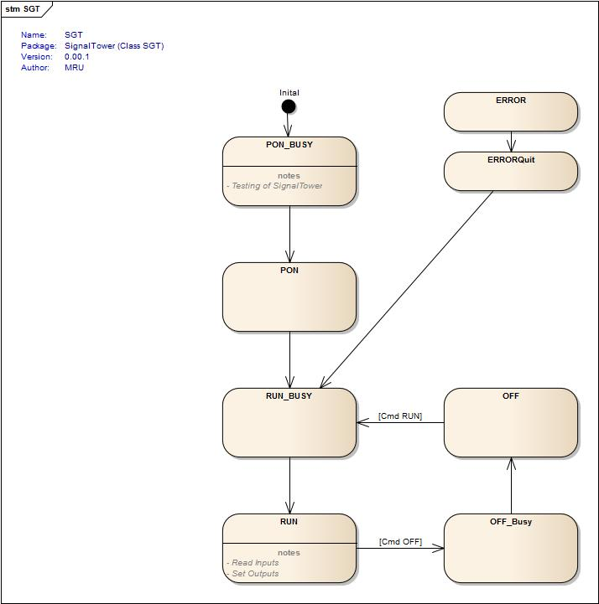

**Commands**

* PON (Lamp function test, if activated. Goes automatically to RUN)
* OFF (With Cmd RUN back to RUN)
* RUN (Can be stopped by Cmd OFF)

**Configuration**

|  |  |  |
| --- | --- | --- |
| *Variable* | *Datatype* | *Description* |
| bolEnableLampTest | BOOL | Enable lamp test in PONBusy state |

**Parameter**

|  |  |  |
| --- | --- | --- |
| *Variable* | *Datatype* | *Description* |
| udiBlinkTime_ms | UDINT | [ms] Blink interval time |
| udiBeepOnTime_ms | UDINT | [ms] Beep on time |
| udiBeepOffTime_ms | UDINT | [ms] Beep off time |
| udiLampTestTime_ms | UDINT | [ms] Lamp test time, used in PONBusy |

**Current Values**

**Outputs**

|  |  |  |
| --- | --- | --- |
| *Variable* | *Datatype* | *Description* |
| bolGreen | T_Ctrl_IoBool | green lamp |
| bolYellow | T_Ctrl_IoBool | yellow lamp |
| bolRed | T_Ctrl_IoBool | red lamp |
| bolBeep | T_Ctrl_IoBool | acoustic signal |

**Inputs**

|  |  |  |
| --- | --- | --- |
| *Variable* | *Datatype* | *Description* |
| In_bolYellowOn | BOOL | Yellow lamp ON |
| In_bolRedOn | BOOL | Red lamp ON |
| In_bolBeepOn | BOOL | Beep ON |
| In_bolGreenBlink | BOOL | Green lamp BLINK |
| In_bolYellowBlink | BOOL | Yellow lamp BLINK |
| In_bolRedBlink | BOOL | Red lamp BLINK |
| In_uinCntGreen | UINT | Counter Green (Blink by change, On by Value > 0) |
| In_uinCntYellow | UINT | Counter Yellow (Blink by change, On by Value > 0) |
| In_uinCntRed | UINT | Counter Red (Blink by change, On by Value > 0) |
| In_uinCntBeep | UINT | Counter Beep (Blink by change, On by Value > 0) |
| In_bolReset | BOOL | Reset Input (Copy changed values to shadow variable) |

**Errors**

* No Error exist at the moment

## 